**Product Features：**  
* IP56 waterproof outdoor unit.   
* Outdoor camera with rain shade can avoid direct sunshine.   
* Intercommunication is available between indoor unit and outdoor unit.  
* Damage-proof outdoor unit.  
* High definition camera, Night vision.   
* Hands-free intercommunication.   
* Monitoring the outdoor.   
* Brightness, chroma and ring adjustable.   
* 8-chord melody rings for option.   
* DIY installation.

**Tchnique Parameter**Adapter input Voltage:AC100-240V 50Hz-60Hz Dual-Voltage.  
Adapter output Voltage、Current:DC15V 1500mA  
Talk time delay:120S ±10%  
Monitor time delay:40S ±10%  
Dissipation: stand by＜0.5W, Working ＜10W  
Working Temperature :-35℃～55℃  
Relative humidity:10%-90%(RH)

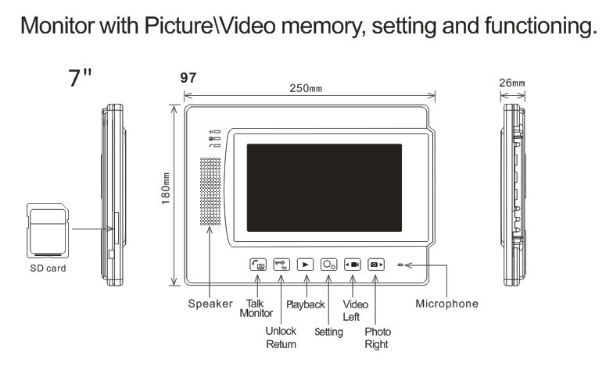

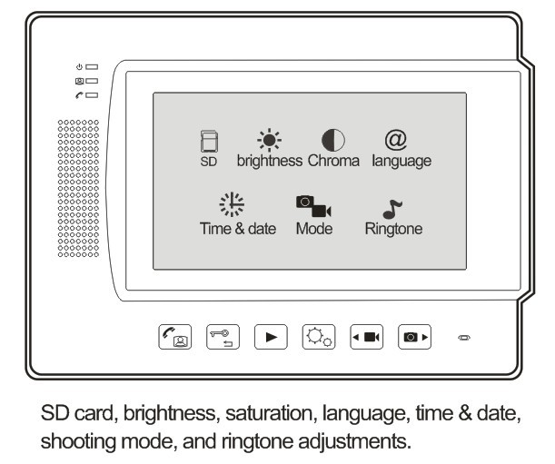

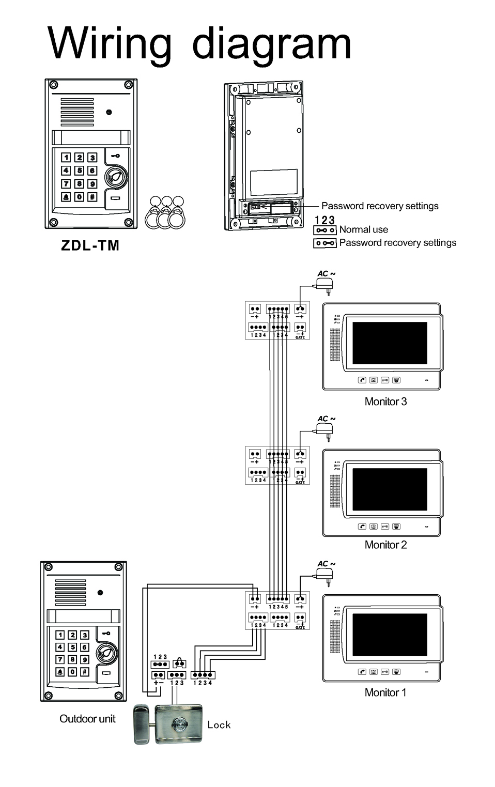

Main setting  
1 Pressing calling button from the outdoor unit, indoor monitor display image.  
2 Pressing monitoring button, indoor monitor display image.  
3 Taking a picture automatic or automatic a 10 S video are optional   
[take photos or videos triangular icon flashes when prompted]

Button operation on monitor:  
Monitoring interface, button operation  
Playback button: View photo or video  
Video button: Video 10S  
Image button: Take one picture  
Monitoring button: Standby  
Back button: Returns to the calendar interface

Enter the menu interface, button operation  
Video button: right  
Image button: left  
Monitoring button: to confirm entry  
Back button: Returns to the previous menu  
Playback button: View photo or video

Parameter Description  
LCD driver 800 X 480  
Photo format JPEG standard   
Video encode MJPEG standard, AVI file   
The video input CVBS analog video input  
FLASH memory 2MB Flash, store 50 pictures.  
TF / SD card storage Default TF / SD card 2GB (maximum support 32GB)  
Length of a single video file 10 seconds  
Working voltage DC15V ± 1V  
Operating Current 330mA  
Start-up time 1 second  
Working Temperature -35 ℃ ~ +55 ℃

